WELCOME TO THE SCOUT HOUSE IN LILLESAND
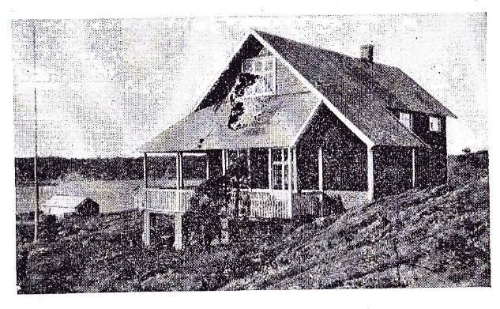
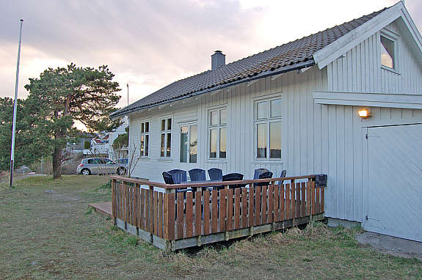

Welcome to the Scout house in Lillesand. This house was built in 1926 by 1st Lillesand scout troop, and has been in the scouts' ownership since then. The exception was the war years 1941-1945 when the Nazis confiscated the house, and the scout movement was banned in Norway.

Today the Scout house is used by the Lillesand Scout and Guide troop for weekly scout meetings. The house is for rent during the summer months and on weekends.

Lillesand Scout group was founded on 23rd April 1913. This was only six years after the Scout movement was founded in England in 1907, by Sir Robert Baden-Powell. The Lillesand Scout group is therefore one of the oldest scout groups in the country and has a long and interesting history. In connection with the 100th anniversary of Lillesand Scout group in 2013, a book was written about the history of scouting in Lillesand. This book can be purchased for 200 NOK by contacting the Scout group:

Contact information to Lillesand Scout Group:
Email: lillesand@speiding.no
http://lillesand.speiding.no

We wish you a pleasant stay in Lillesand. Please leave the place in the condition you want to find it. If you find defects that should be corrected, please contact us. We would like to fix this before the arrival of next rental.
RULES AND REGULATIONS
- Any damage to the property should be reported in the report form. Renters must pay for all costs associated with damaged, or missing property,
- Please remember that it is required that you leave the house thoroughly clean and tidy, as it was at your arrival. We have provided a checklist for your use prior to your departure.
- Smoking inside the house is not permitted.
- On departure: Please leave the key in the key safe box.
- Please follow the Lillesand recycling system: Sorted waste should be placed it in the three waste bins provided outside the house, or as described below:
  - Brown recycle bin: Food waste: disposed in green bags.
  - Green recycle bin: Paper or cardboard.
  - Black recycle bin: Residual waste
  - Plastics: put in a separate plastic bag (found under the kitchen workbench)
  - Glass (clear/coloured) and metal packaging: Emptied by the tenant at garbage sorting station at Lillesand marina.
  - Please bring bottles to the bottle return. Bottle Return machines can be found at most supermarkets and stores.

- The key to outdoor tap (water hose) is placed in the fuse box (in the entrance). Please save water! In summer there are water restrictions in Lillesand.
- For questions related to waste and water: please contact Lillesand municipality:
phone +47 37 26 15 00
- Check in time: Sunday after 2 pm (16:00). Check out time: Saturday prior to 12 am.
- Please fill in the check list and leave it in the house at departure. Alternatively, send the form to us by email: lillesand@speiding.no
Your feedback is highly appreciated and will help us to improve the scout house for the next guest.

